Lesson Title: California Culture: Surf History and Beyond
Grade Level: 10th
Subjects: Writing, Research Paper, California Culture, Surf History, Photography
Class Sessions: Two
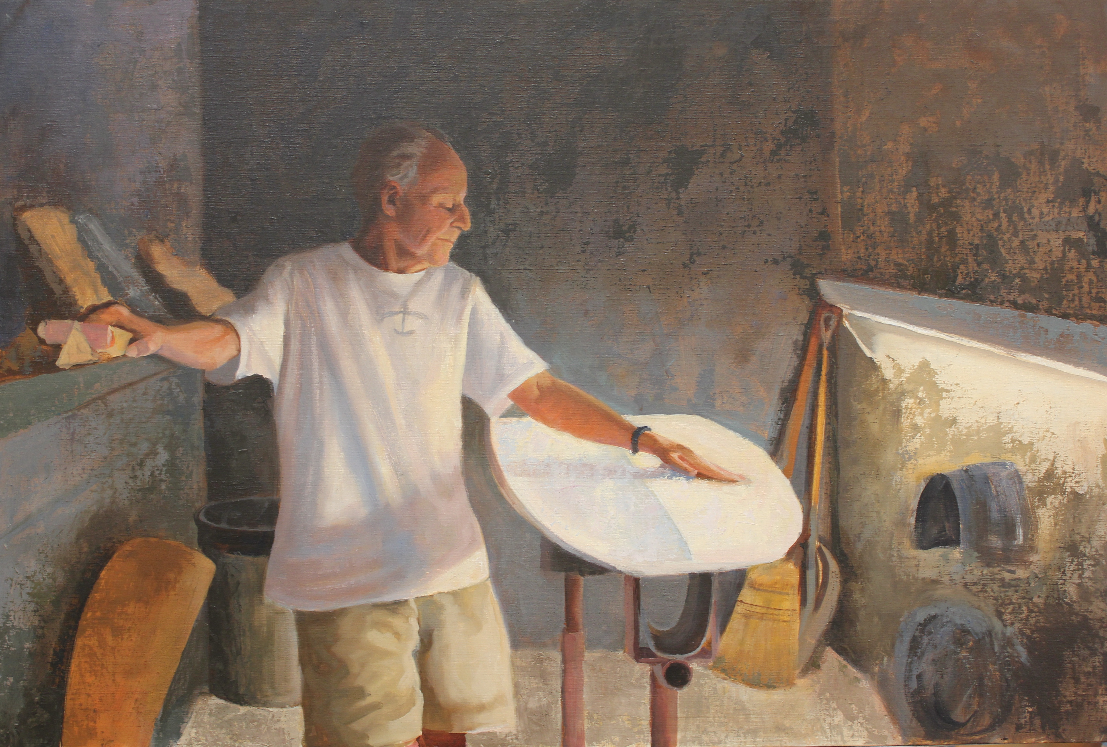
Lesson Summary: California is synonymous with surfer culture. But, how did the first surfboards make their mark in California? Reynolds Yater is a living piece of surf history and known as one of the finest surfboard crafters in the world. His story offers a relevant touch point for student’s learning to write longer, more technical papers. Students will examine Yater’s multimedia story as told by Portraits of the Central Coast and then create a research paper based on a similar element of California history.

Lesson Objectives: Students will learn how photography and recreational activities have an impact on a state’s cultural perception. Students will learn more about the process of creating a research paper on a cultural/anthropological topic.

Materials
-Portrait of Reynolds Yater by Holli Harmon
-Video Interivew of Reynolds Yater on portraitsofthecentralcoast.com
-Essay on Reynolds Yater from portraitsofthecentralcoast.com
-http://www.library.ca.gov/calhist/photoarchives.html or a similar archive website where students can access photos and other sources from 1950-1960.
- http://www.sbsurfingmuseum.com/ - Surf Museum
- http://surfnwear.com/ - sells Reny’s boards

Lesson Plan:
- Talk about what kinds of culture we associate with in different states.
- See, Think, Wonder with Reynolds Yater’s portrait
- Hand out a page of focus questions to help students think about Yater’s video interview
- Discuss Yater’s impact on California Surf History
  - What did carefully crafted surfboards do for the surfing community?
  - Who could surf in Yater’s time?
  - In what ways is surfing a professional sport?
5. Potential discussion of California context in the 50s.
6. Divide students in Brainstorm groups to pick topics for their research paper
7. Outline next steps for research paper on an aspect of California History that has an object and photographic history.

Assessment:
- The research paper as graded by the standards below
- Ability to work in a group for brainstorming projects
- Contribution to class discussion

Standards Addressed
CCSS Standards for Writing 9-10th
Text Types and Purposes
1, a.b.c.d.e Write arguments to support claims in an analysis of substantive topics or arguments to support claims in an analysis of substantive topics or texts, using valid reasoning and relevant and sufficient evidence.

Research to Build and Present Knowledge
7. Conduct short as more well sustained research projects to answer a question (even a self-generated one) to broaden a perspective, narrow a scope . . . synthesize multiple sources to demonstrate understanding of a topic under investigation.

8. Gather relevant information from a variety of authoritative print and digital sources . . successfully integrate information into text while maintaining flow and avoiding plagiarism.

