Lesson: Innovators in Their Field: A Discussion Guide
Grade: 10th-12th
Subject: Innovation, Transition, Legacy, The Organic Movement
Class Sessions: 1-2

Materials:
Portrait of Richard and Thekkla Sanford by Holli Harmon
Interview of Richard and Thekkla Sanford
Portrait of the Duke and Duchess of Urbino by Piero della Francesca
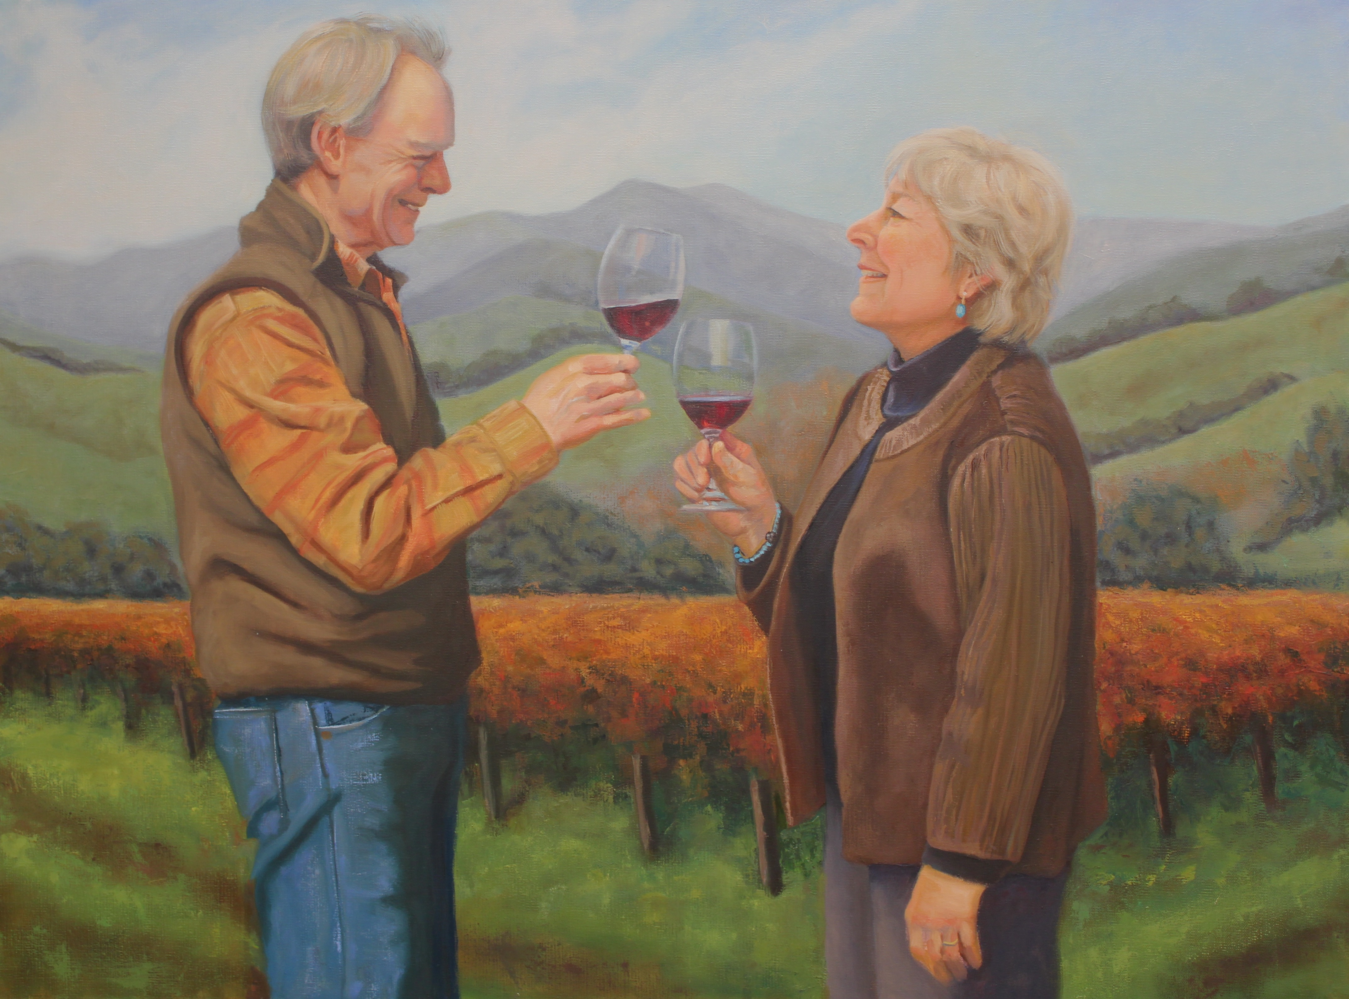
Discussion Questions
- What makes Alma Rosa wine distinct? Why must do we describe wines as distinct and particular?
- Richard got into agriculture after coming home from Vietnam, how do you think the vineyard contributed to his management of potential PTSD?
- In what ways does managing a vineyard require creativity?
- Is the Sanford’s approach for their vineyard and their wine innovative? Why or why not?
- Discuss the following quote as it relates to your life: “I think there is something in our genetic code or our own Manifest Destiny that has brought all of us here to the Central Coast. Either, within ourselves, or in the temperament of our fore fathers, we are adventurers, free thinkers and/or entrepreneurs. These are all common traits you find in gold miners, immigrants and hippies, all of which have made up our collective California culture.”
- Investigate the various ecological and farming tehcniques the Sanfords brought together, how did this advance their wine as a quality wine?
- What does wine say about Santa Ynez culture and heritage?
- What do we associate wine with?

Essay Questions

- Research how climate affects food growth. How can this knowledge assist farmers worldwide?
- Look up some other stories about viticulturists or winemakers in the Santa Ynez Valley: compare and contrast their stories to Richard and Thekkla Sanford’s.
- Reflect on the following quote and talk about how it relates to the idea of legacy: “While Richard brought his understanding of the land and agriculture to winemaking, Thekla brought her love of nature and community. The arc of their commitment starts with organic farming and sustainable agriculture and includes ecological packaging, green building, wildlife protection and culminates in the slow food movement, which addresses the quality of the food we eat.”
- In the video, notice how the Sanford’s daughter strategically picked colors for each of the wine bottles. Investigate wine bottle labeling and talk about the relationship between color and product.

